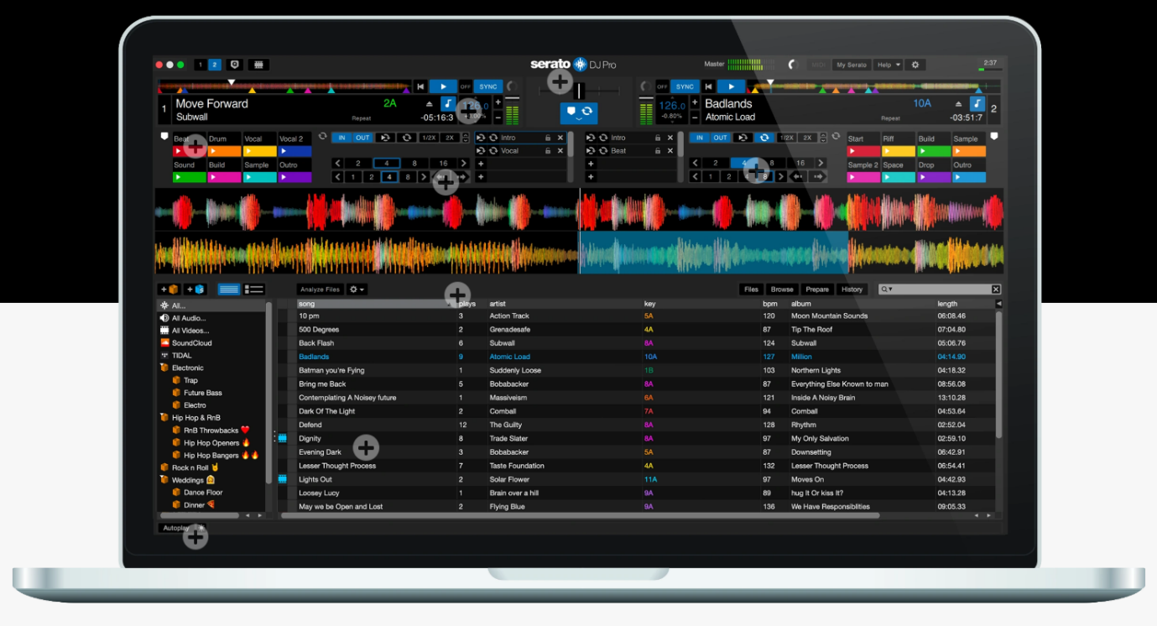**Become a Serato DJ**

**Introduction:**

From the unknown to the greatest, Serato DJ Pro is the most popular DJ software globally. When you’re talking about Hip-Hop, Dance, and everything in between, you’re looking at the standard. Whether you are starting out or experienced, you too can be a DJ.

With Practice Mode in Serato DJ Pro, you’ll be able to mix two tracks together, set and trigger Cue Point and Loops, all without the need to connect hardware. Practice Mode means you can now DJ anywhere you have your laptop.

**Objectives:**

You will be able to:

* install Serato DJ Pro software
* add music media to your library
* load, play and mix 2 songs simultaneously
* trigger loops and cues and other features
* connect hardware for advanced users
* be the envy of any party